In the name of wisdom

Modern control project

Professor: Dr.Majid Hajatipour

Student: Amirhossein Shoaraye Nejati

School of electrical and computer

Engineering

Kashan university

Winter 2019

In this project we are trying to investigate a single input-output system and its properties like its poles, different responses, stability situation and also install different kinds of state feedback on it in order to guarantee its stability.

Furthermore, we like to study an observer on this system to understand its mechanism. In this paper we used MATLAB coding for calculations and solutions and also MATLAB Simulink for several simulations.

At first, we have to assume a controllable and observable but unstable system. In this study we choosed a 3rd degree system which its poles located at :( 3,-2,-and 1) and by a transfer function like this: $\frac{(S+5)(S+4)}{(S-3)(S+2)(S+1)}$

Next, we must design its state feedback which should be able to change its poles locations to:(-3,-4,-5)

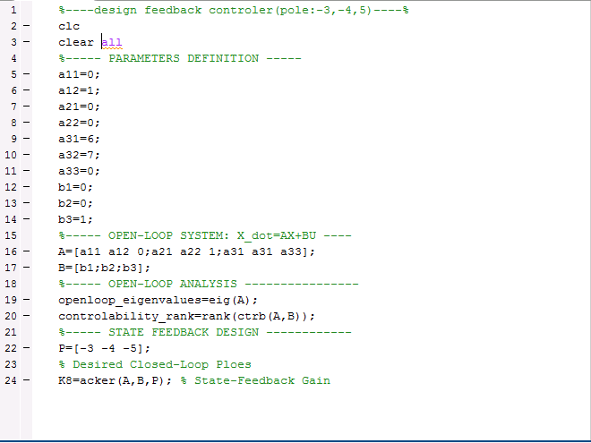

As it is obvious, in this code we consider our system parameters after that we check its construability and then we calculate state feedback Gain by acker function:

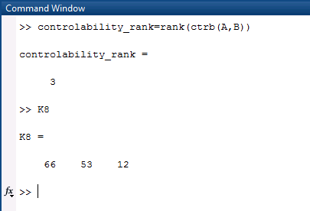

Now we install this state feedback on our system and perceive its responses in Simulink:

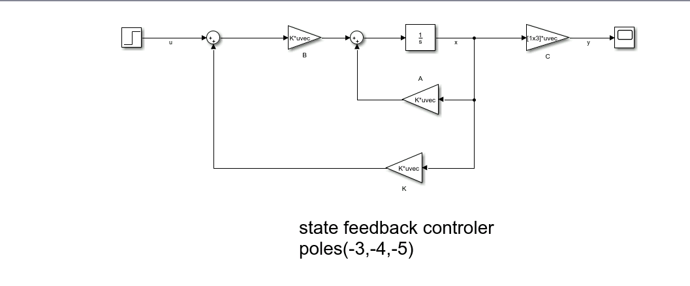

First we observer system response without feedback part and then by this system:

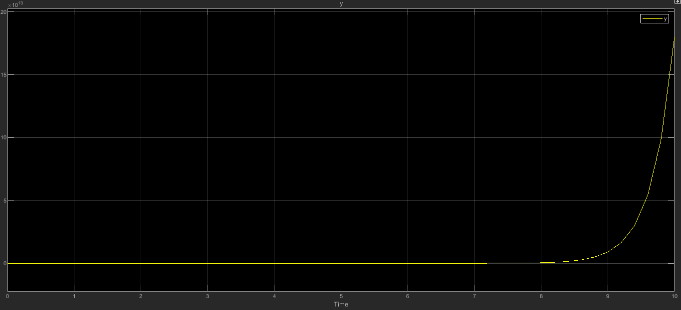

By feedback system:

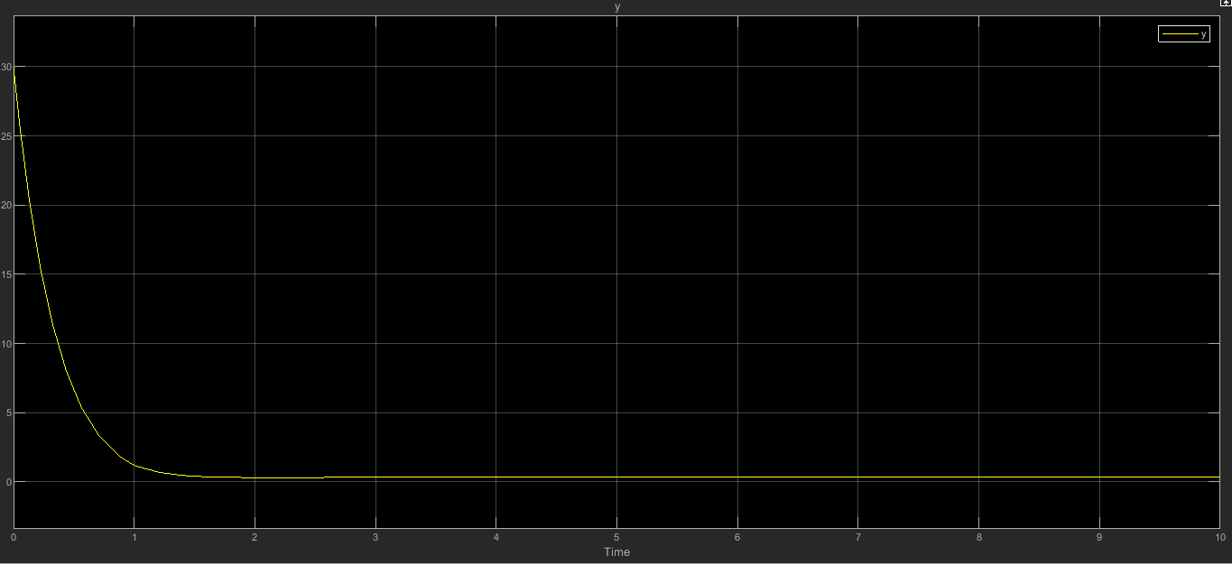

It can be understood that by installing feedback system we have guaranteed system stability.

Also we can see system state signals and control signal in this diagram:

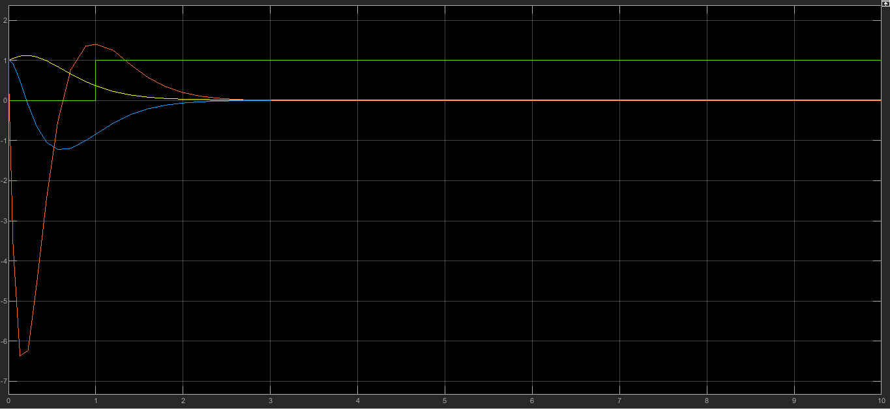

Now we can try a state feedback system by an integral controller so we will be able not only control system stability also make it follow a step input in its output:

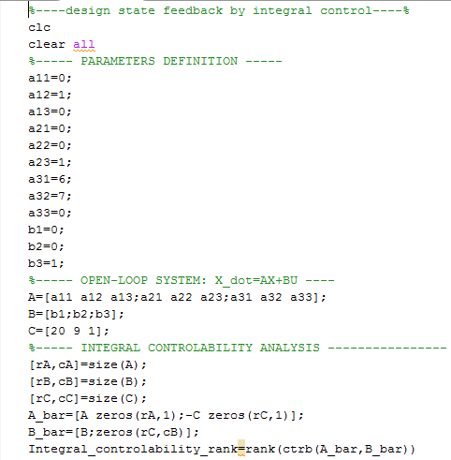

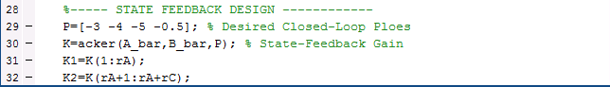

In this code at first we assume our system, then we check controllability of the system and finally calculate K1 as feedback gain and K2 as integral gain.

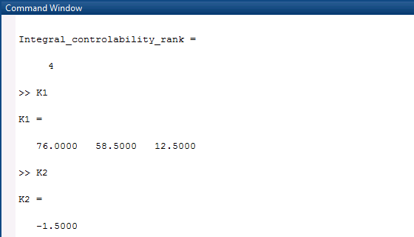

Now we can observe system response to a step input:

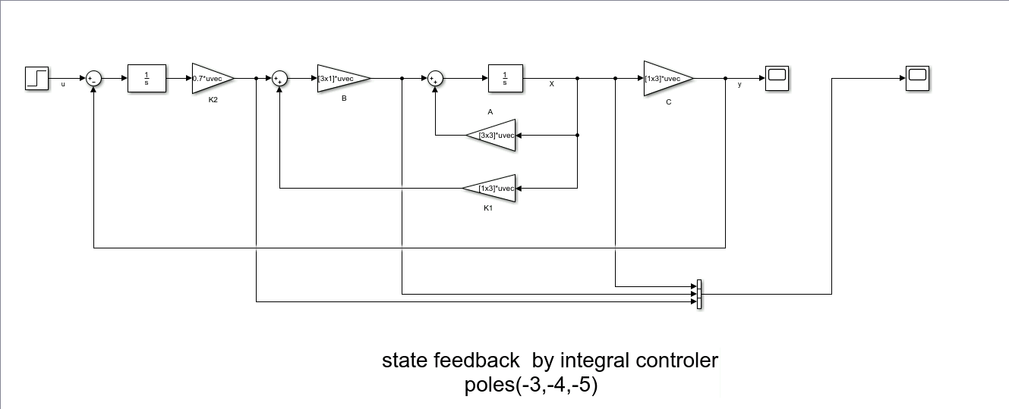

Let’s consider this system properties diagram:

First its output:

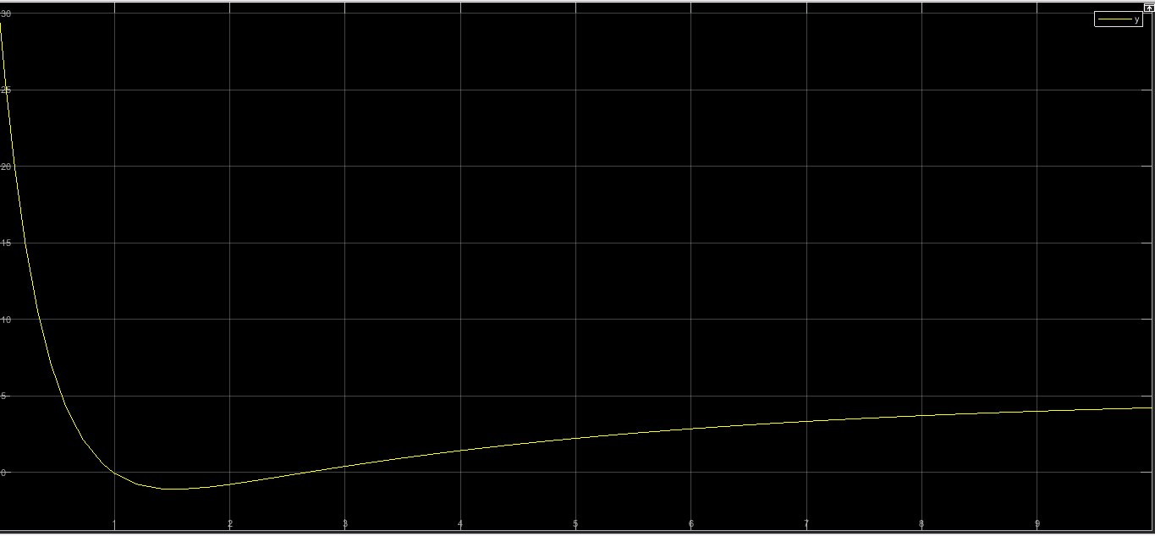

The point that we should notice in this diagram is integral gain. The higher it’s become, we have shorter response time to follow step input.

State signals and control signals:

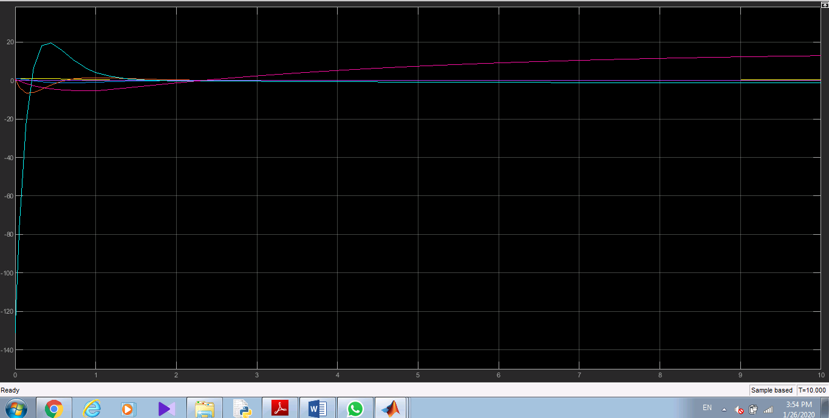

Now we want to repeat what we have done so far by these selected poles for feedback system:(-1,-1,-1)

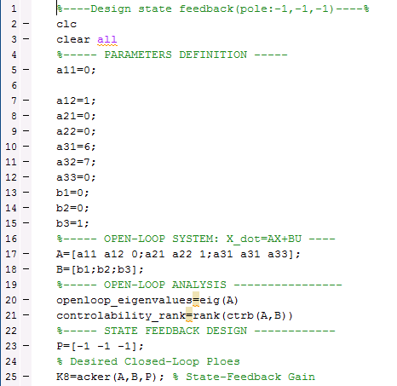

Results:

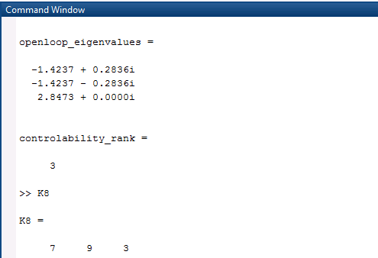

Diagrams:

A) Output:

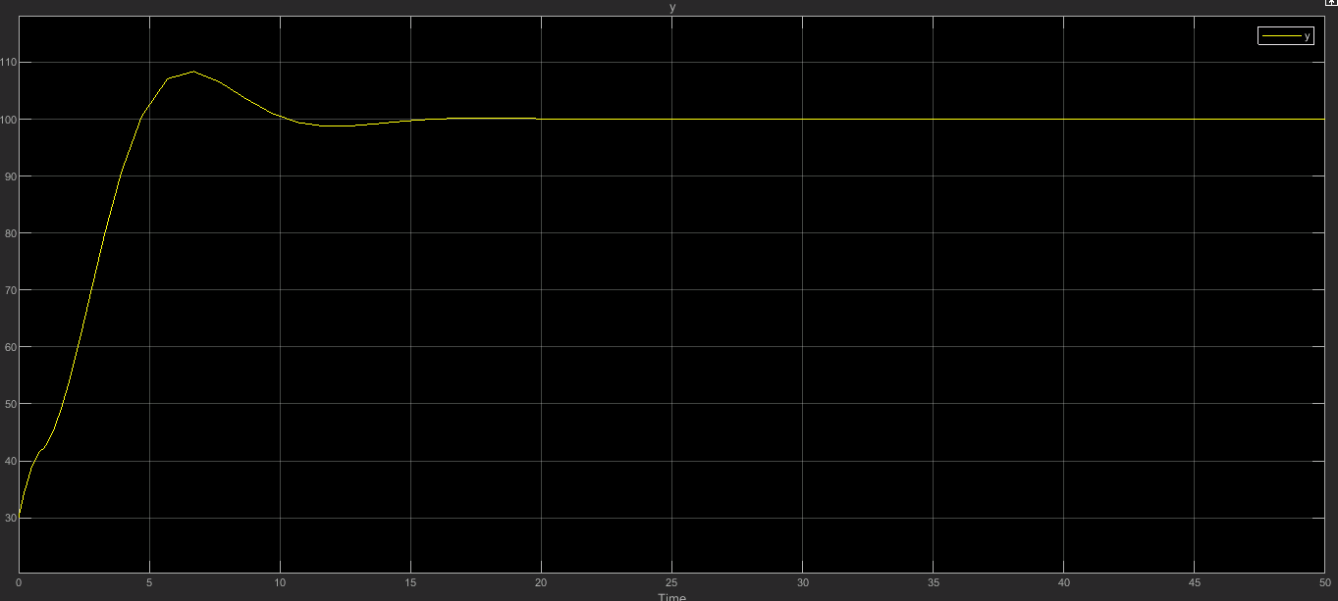

b) State signals and control signal:

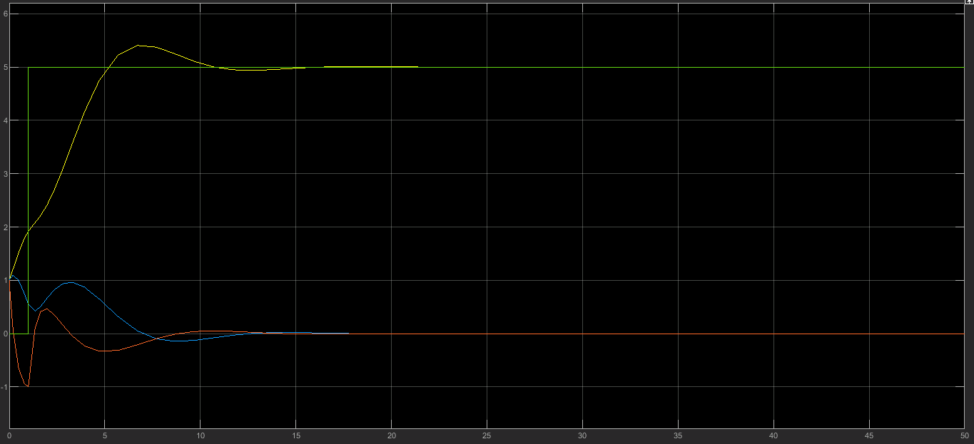

Designing integral feedback system:

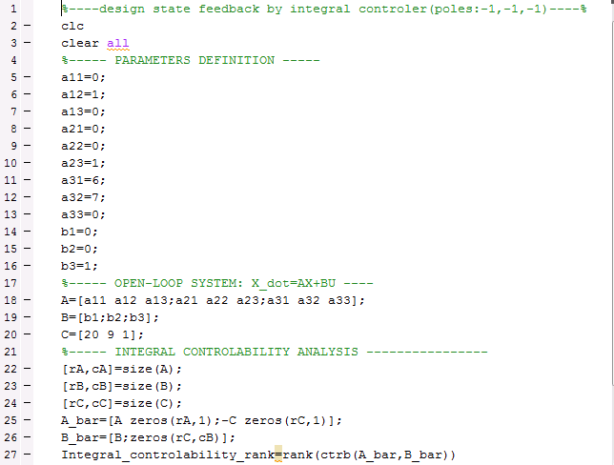

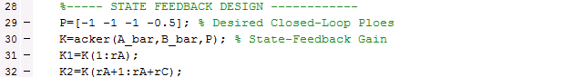

If we want to talk about the comparison between these two simulated integral feedback system, we should say because the poles of the second system is closer to the center, the system has lower response time but in contrast with the first model if we choose a great number for integral gain the output will be unstable.

After that now we want to design an observer which it poles located in:(-10,-10,-8)

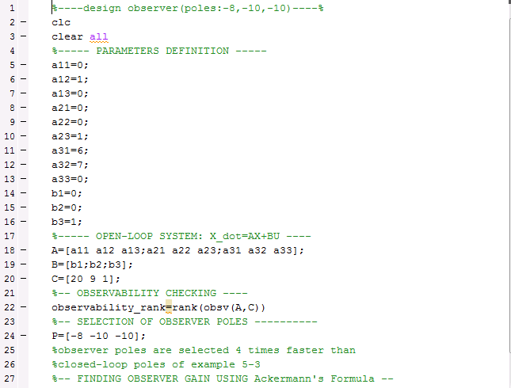

C:\Users\amir\Desktop\partF2.PNG

If we take a closer look to the codes we can understand that at first we assume the system parameters, then we checked system observability and finally we calculated the observer gain.

Let’s its schematic in MATLAB Simulink:

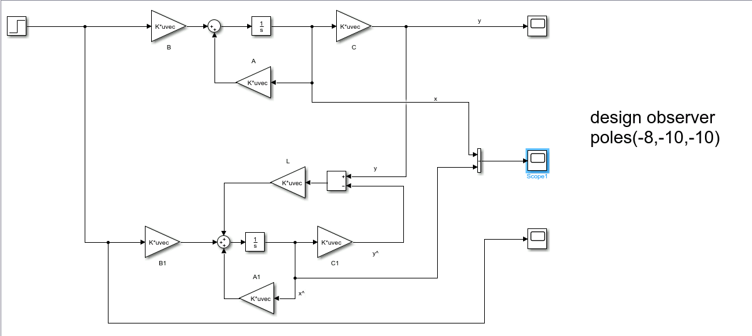

Let’s compare the main system response and what our observer achieved:



We can see our observer did a good job and approximately we have a same response in two diagram.

Then we want couple this observer to our previous state feedback and see what will happened:

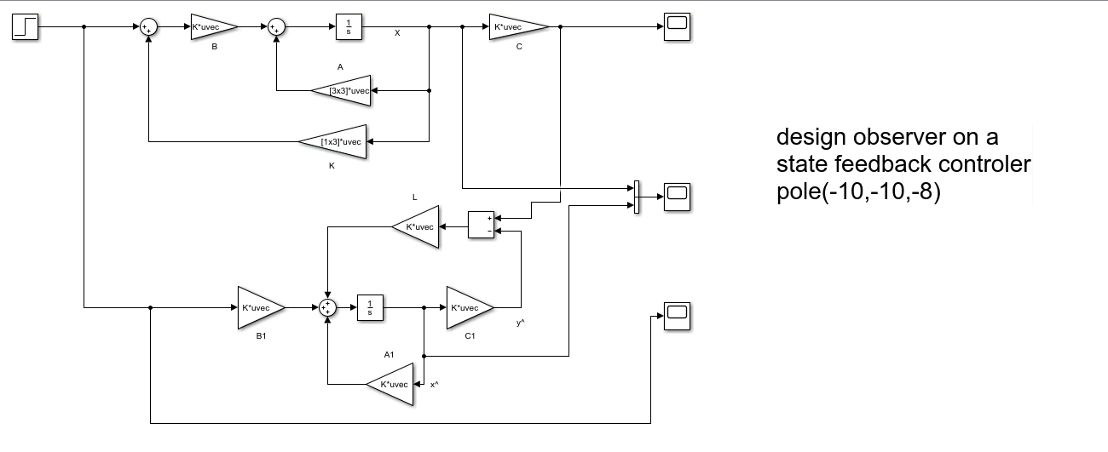

And in this diagram we can consider state signals:

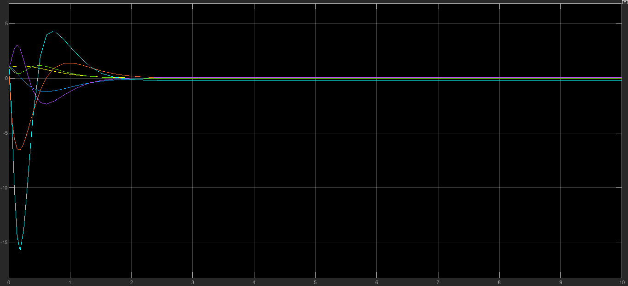

Finally we have to install our observer on an integral state feedback:

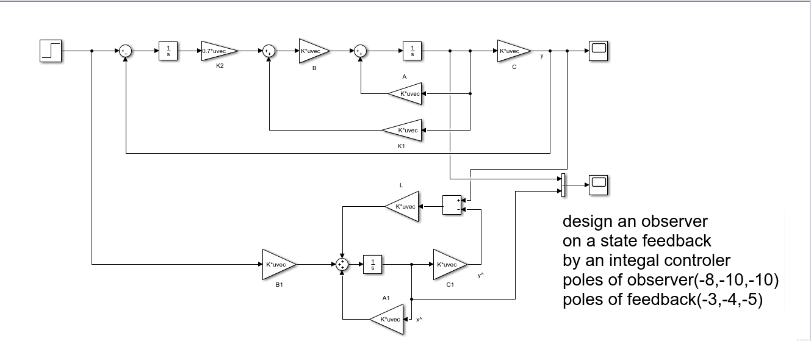

State diagrams:

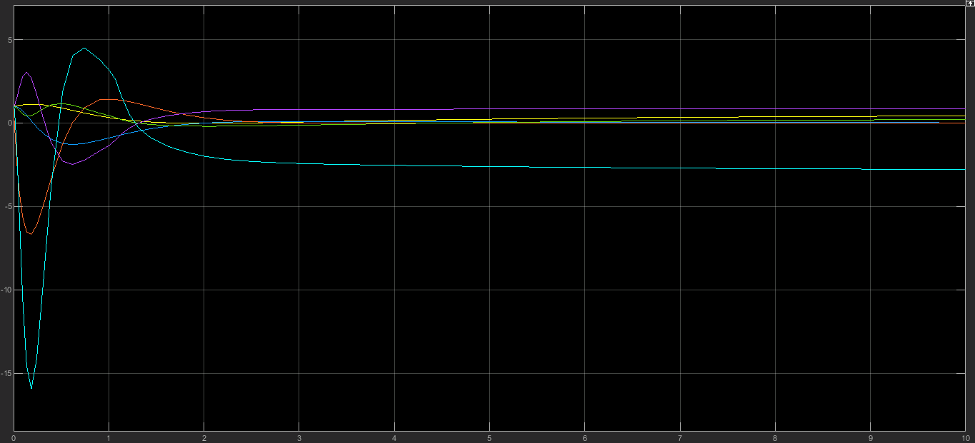  
We can understand that inspite of extinction of observer, approximately all of our states finally goes to zero and we have stable system.